|  |
| --- |
| UZB DESIGN AND DEVELOPMENT |
| The Dark Knight's Gotta Catch Em All |
| **[COMP 397]** |
| Version #1.1  All work Copyright © 2012 by XX Games.  All rights reserved. |
| **Noel Euzebe]** |
|  |



|  |
| --- |
| Nov 10th 2014 |

**Table of Contents**

Contents

[Version History 3](#_Toc403415341)

[Game Overview 4](#_Toc403415342)

[Game Play Mechanics 4](#_Toc403415343)

[Character 4](#_Toc403415344)

[Enemies 4](#_Toc403415345)

[Controls 4](#_Toc403415346)

[Screen Description 5](#_Toc403415347)

[Scoring 6](#_Toc403415348)

[Art Index 6](#_Toc403415349)

[Sound Index 7](#_Toc403415350)

# Version History

Version 1.0

* Created basic functionality
* Added to version control

Version 1.1

* Added GUI and image assets

## Game Overview

*The Dark Knight's Gotta Catch Em All is a side-scroller in which the player's objective is to get as many points as possible while staying alive. Players get points by collecting PokeBalls and lose lives if hit by bullets. The game is theoretically never ending as long as the player never loses all his or her lives.*

### Game Play Mechanics

*The player controls The Dark Knight by pressing the Spacebar to make him jump. Correct timing of the jump is required both to dodge the bullets that can kill the Dark Knight as well as to capture the PokeBalls, which gives points. For each bullet that hits the player, the player loses a life. For each PokeBall that is captured, 50 points are gained. When the player's points are a multiple of 500, the player earns an extra life. When the player loses all his or her lives, the game is over.*

### Character

The character which the player controls is an avatar of Batman: The Dark Knight.

### Enemies

The enemies in the game are bullets, which jet across from the right side of the screen towards the player. If the enemy collides with either the player or the left edge of the screen it resets to off the right side of the screen, to approach the player again. To make the game less predictable, the speed of the enemy is randomised each time the enemy resets.

### Controls

*The keyboard is used to make the character jump.*

Screen Description  
  
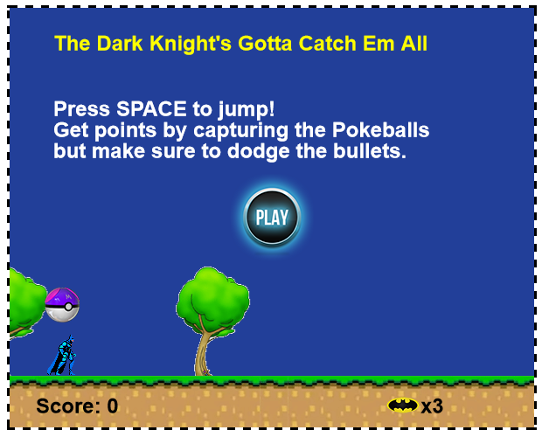  
 Start Screen  
  
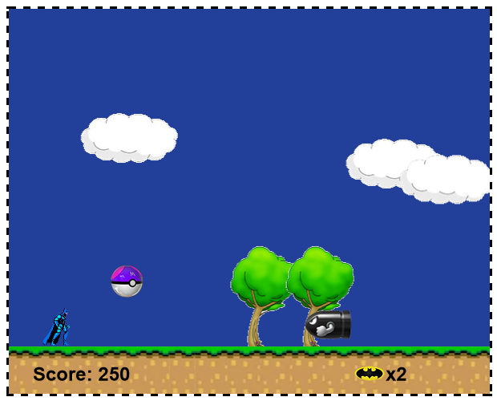  
  
 Gameplay Screen

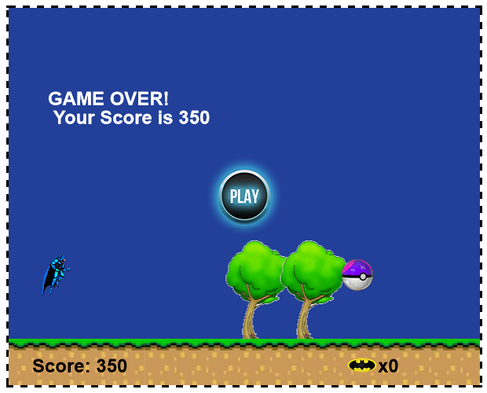

Gameover Screen

### Scoring

Score is increased when the player collects PokeBalls. This score is tracked by the Score meter in the interface.

### Art Index

C:\Users\NOEL\Dropbox\Centennial\Semester 6\COMP 397\side_scroller\side_scroller\images\character.png C:\Users\NOEL\Dropbox\Centennial\Semester 6\COMP 397\side_scroller\side_scroller\images\bullet.png C:\Users\NOEL\Dropbox\Centennial\Semester 6\COMP 397\side_scroller\side_scroller\images\coin.png C:\Users\NOEL\Dropbox\Centennial\Semester 6\COMP 397\side_scroller\side_scroller\images\life.png

C:\Users\NOEL\Dropbox\Centennial\Semester 6\COMP 397\side_scroller\side_scroller\images\cloud.png

C:\Users\NOEL\Dropbox\Centennial\Semester 6\COMP 397\side_scroller\side_scroller\images\ground.png

### Sound Index

* gameover.ogg - Sound effect used when the player's lives run out
* powerup.ogg - Sound effect played when player earns an extra life
* yahoo.ogg - Sound effect played whenever the player collects a PokeBall
* damage.ogg - Sound effect played whenever the player takes damage